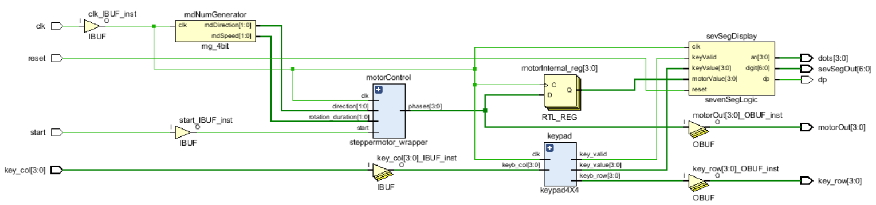
Project Schematic

Inputs:
- clk: Clock input which is used synchronise the circuit using the clock signal from the BASYS3 board.
- start: Required input of the steppermotor_wrapper module. It is used to initiate the movement of the stepper motor.
- key_col[3:0]: Required input of the keypad4X4 module. It will be used to take player inputs from the keypad.
- reset: This input is used to reset the score of the player. It is connected to sevenSegLogic module and it will be used to reset the register in it.

Outputs:
- motorOut[3:0]: Required output of the steppermotor_wrapper module. It will be stored in a register and then will be output to the stepper motor, controlling its movements.
- key_row[3:0]: Required output of the keypad4X4 module. It will be used to determine the input of the player as part of the keypad logic.
- dots[3:0]: Required output of the sevenSegLogic module. It will be used to control the decimal points on the seven segment display.
- sevSegOut[6:0]: Required output of the sevenSegLogic module. It will be used to control the digit display on the seven segment display to show the score of the player.
- dp: Required output of the sevenSegLogic module. It will be used to control the dots on the seven segment display.

Modules:
- rng_4bit: Module used to randomize the stepper motor movements. Takes only clock input and outputs one bus of size two for direction and one bus of size two for speed. These outputs are then passed onto the steppermotor_wrapper module.
- steppermotor_wrapper: Module used to control the stepper motor. Takes inputs clock, start, and two buses of size two for direction and speed. Outputs a bus of size four to control the stepper motor. Start input is used to initiate the motor movement, input buses are used as part of a logic to determine the output for motor movement. The output is then passed to stepper motor and a register to hold the values to compare in sevenSegLogic module.
- keypad4X4: Module used to take player input from a 4x4 keypad. Takes inputs clock and a bus of size four for keyboard columns. Outputs a bus of size four for keyboard rows as part of the keypad logic, a bus of size four for input value and a single bit as a flag for the valid key press. Outputs for valid key and input value are then passed to sevenSegLogic to determine the new score.
- sevenSegLogic: Module used to control the seven segment display and it includes SevSeg_4digit module given as part of the project. Takes inputs clock, a single bit for reset, a single bit for valid key press and two buses of size four for key value and motor value. Reset input is taken from the player and it is used to reset the score. Buses for key value and motor value are compared inside the module to determine whether the player input was correct. Then result of that comparison is used to determine the new score and through the use of SevSeg_4digit module the new score will be displayed on the seven segment display.

